**ASSIGNMENT-4**

1. **What should be the output? ( 3 + 4 ** 6 - 9 * 10 / 2 )?**

Ans. 

1. **Let say I have, some string "hello this side regex"**

**Find out the count of the total vowels**

**○ vowels - ['a','e','i','o','u']**

Ans. 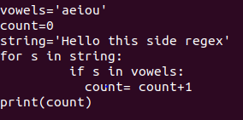



1. **Find out the area of triangle**

**1/2 * b * h (formula of area)**

**You have to take value from user about the base, & the height**

Ans. 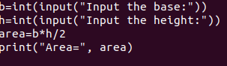

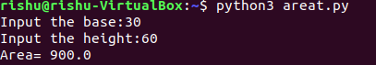

1. **Print the calendar on the terminal. If you give the year, allow the user to input the year. Then, show that calendar of that year.**

Ans. 